Comparative Analysis of Accuracy on Heart Disease Detection using Data Mining Classification Techniques

K.K.Revathi
Research Scholar,
Dept. of Computer Science, Selvamm Arts & Science College (Autonomous) Namakkal.
Tamilnadu, India
e-mail: revathikkmca@gmail.com

K.K.Kavitha
Vice Principal, Head of the Department,
Dept. of Computer Science, Selvamm Arts & Science
College (Autonomous) Namakkal.
Tamilnadu, India
e-mail: kavithakkcs@gmail.com

Abstract: Today’s world in all fields extract useful knowledge from data, Data Mining is an analytic process designed to explore data. Classification analysis is one of the main techniques used in Data Mining. It brings up the differences between different models and evaluates their accuracies in detecting a problem in various aspects. In this work, we focus on Heart Disease problem; specifically we took University of California (UCI) heart disease dataset and WEKA (Waikato Environment for knowledge Analysis) data mining tool. Various researches have investigated this dataset for better prediction measures. In our paper does a comparative study of commonly used machine learning algorithms to detecting heart diseases. The aim of this research to judge the accuracy of different data mining algorithms such as naive bayes, IBK, random forest on heart disease dataset and determine the optimum algorithm for detection of heart disease.

Keywords: Data Mining, Classification, Bayesian, lazy, IBK, random Forest, WEKA, naive bayes

Introduction
Heart Disease is a very fatal and dangerous disease because if patient ignores its earlier symptoms, which seems to be a warning signs, it gives no time to patient for recovery and eventually may lead to death on spot. This is called as heart attack. So find out correct classification algorithm to detect heart disease problem in early [11].
Data can be in any form like facts, text or numeric which can be computed by computer [1]. This data when converted to meaningful data becomes information. Data Mining is process of finding knowledge from huge collection of data. It has various methods to extract hidden knowledge from large data set. Techniques like association rule mining, classification and clustering can be used to analyze data. Classification is the process of finding a set of models that describe and distinguish data classes and concepts, for the purpose of being able to use the model to predict the class whose label is unknown. This data is used for further analysis to generate patterns. Using data mining techniques on heart disease data set with the help of weka tool, we can detect whether the person attack heart disease or not. To utilize this method and detect the problem, it may help to reduce death rate.
In this paper we described the analysis of three different algorithms on the basis of various performance parameters. Simple Description of these algorithms are as follows,
- Naïve Bayes is simple, efficient and good performance in classification. It also provides good accuracy for general purpose analysis. Due to its good accuracy it can be used in medical diagnosis.
- Random forest algorithm is a supervised classification algorithm. As the name suggest, this algorithm creates the forest with a number of trees. In machine learning way of saying the random forest classifier. Random forest algorithm can use both for classification and the regression kind of problems.
- IBK may refers to: IBK algorithm is implements from the k-nearest neighbor algorithm, In weka it is called as IBK (Instance-Bases learning with parameter k) and it is in lazy class folder. In machine learning it sometime called as memory-based learning. Examples of instance-based algorithm are k- nearest neighbor algorithm, kernel machines and RBF networks.

background of the study
V. Manikantan & S.Latha are proposed Medicinal data mining methods. Medical data mining content mining and structure methods are used to analyze the medical data contents. They used heart disease dataset. The term Heart disease encompasses the various diseases that affect the heart. The data classification is based on MAFIA algorithms which result in accuracy, the data is evaluated using entropy based cross validations and partition techniques and the results are compared. They are used the C4.5 algorithm as the training algorithm to show rank of heart attack with the decision tree. Finally, the heart disease database is clustered using the K-means clustering algorithm, which will remove the data applicable to heart attack from the database. The results showed that the medicinal prescription and designed prediction system is capable of prophesying the heart attack successfully.
Divyansh Khanna, Rohan Sahu, Veeky Baths, and Bharat Deshpande were proposed comparative study of data mining classification techniques such as, logistic regression and support vector machine using Cleveland Dataset and models the classification techniques on it. It brought the differences between the models and their accuracies in predicting a heart disease. They used F1 score and ROC curves as evaluative measures. Through this effort, their aim to provide a benchmark and improve earlier ones in the field of heart disease diagnostics using machine learning classification techniques.
Mythili T., Dev Mukherji, Nikita Padalia, and Abhiram Naidu, proposed the early prognosis of cardiovascular diseases. It can aid in making decisions to lifestyle changes in high risk patients and in turn reduce their complications. Research has attempted to pinpoint the most influential factors of heart disease as well as accurately predict the overall risk using homogenous data mining techniques. Recent research has delved into amalgamating these techniques using approach
es such as hybrid data mining algorithms. This paper proposed a rule based model to compare the accuracies of applying rules to the individual results of support vector machine, decision trees, and logistic regression on the Cleveland Heart Disease Database in order to present an accurate model of predicting heart disease.
Pritam H. Patil,Suvarna Thube, Bhakti Ratnaparkhi and K.Rajeswari, they proposed about Data Mining techniques like classification, clustering, association rule mining. This paper compares performance of different data mining tools like WEKA, XLMiner and KNIME for these data mining techniques. They used Statlog heart disease dataset for analyzing performance of tools.
Ms S. Vijayarani, Ms M. Muthulakshmi proposed about text mining. From this work we knew, the searching of similar documents is an important problem in text mining. The first and essential step of document similarity is to classify the documents based on their category. In this research work, they analyzed the performance of Bayesian and Lazy classifiers for classifying the files which are stored in the computer hard disk. There are two algorithms in Bayesian classifier namely BayesNet, and Naïve Bayes. In lazy classifier has three algorithms namely IBL, IBK and Kstar. The performances of Bayesian and lazy classifiers are analyzed by applying various performance factors. From the experimental results, it is observed that the lazy classifier is more efficient than Bayesian classifier.
.

Methodology
Text classification is one of the important research issues in the field of text mining, where the documents are classified with supervised knowledge. The main objective of this research work is to find the best classification algorithm
among Bayesian, Lazy and Tree classifiers. The system architecture of the research work is as follows:

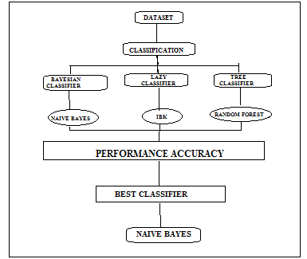
Figure 1: System Architecture of Classification Algorithms

Dataset Description
We have tested the Statlog heart disease dataset (SHDD) on different data mining classification methods such as bayes, lazy, trees. This dataset is taken from the University of California, Irvine (UCI) [9] Machine Learning Database. It contains totally 270 instances of healthy persons and patients with heart problem [11]. It includes class information and total 13 attributes as listed below:
1) Age
2) Sex
3) Chest pain type (four values)
4) Resting blood pressure
5) Serum cholesterol (in milligrams per deciliter)
6) Fasting blood sugar > 120 mgldL
7) Resting electrocardiographic results (values 0, 1, 2)
8) Maximal heart rate achieved
9) Exercise-induced angina
10) Old peak (ST depression induced by exercise relative to rest)
11) The slope of the peak exercise ST segment
12) Number of major vessels (0-3) colored by fluoroscopy
13) Thai: 3 - normal; 6 – fixed defect; 7 - reversible defect.
The class information is included in the dataset as absent and present regarding the absence and presence of heart disease, respectively.

Figure 2: Data set sample

Tool Description
WEKA (Waikato Environment for Knowledge Analysis) [8] is collection of machine learning algorithm for data mining task written in a JAVA. WEKA contains tools for data pre-processing, classification, regression, clustering, association rules, and visualization. WEKA is open source software issued under the GNU General public License.
Weka is a collection of machine learning algorithms for data mining tasks. The algorithms can either be applied directly to a dataset or called from your own Java code. Weka contains tools for data pre-processing, classification, regression, clustering, association rules, and visualization. It is also well-suited for developing new machine learning schemes.

Classification
Classification is an important data mining technique with broad applications. It is used to classify each item in a set of data into one of predefined set of classes or groups. Classification algorithm plays an important role in document classification. In this research, we have analyzed three classifiers namely Bayesian, lazy and trees. In Bayesian classifier, we have analyzed the classification algorithm namely naïve bayes, in lazy classifier we have analyzed the classification algorithm IBK, in tree classifier we have analyzed the classification algorithm namely random forest.

Bayesian Classifier
Bayesian algorithms predict the class depending on the probability of belonging to that class. A Bayesian network is a graphical model for probability relationships among a set of variables features. the Bayesian Network combines the properties of computer science and statistics

Naïve Bayes Classifier:
The Naive Bayes algorithm is based on conditional probabilities. NB uses bayes theorem that is a formula that calculates a probability by counting the frequency of values and combinations of values in the historical data. Bayes' Theorem determines the probability of an event occurring given the probability of another event that has already occurred.
P(c|x)= P(x|c)P(c)/P(x)

- P (c|x) is the posterior probability of class (target) given predictor (attribute).
- P(c) is the prior probability of class.
- P (x|c) is the likelihood which is the probability of predictor given class.
- P(x) is the prior probability of predictor.
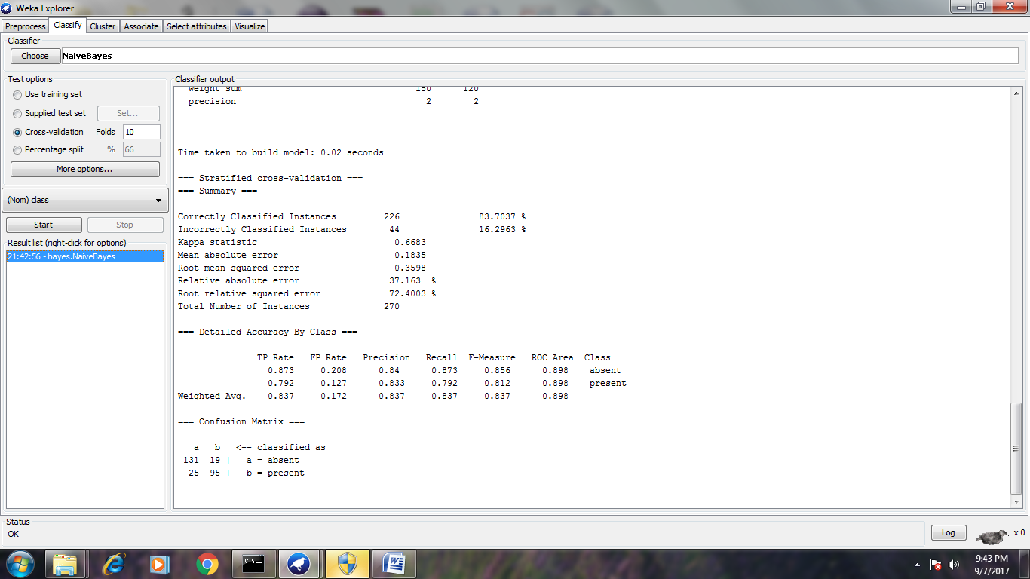

Figure 3: Implementation of Naïve Bayes Classifier

Lazy Classifier
Lazy learners store the training instances and do no real work until classification time. Lazy learning is a learning method in which generalization beyond the training data is delayed until a query is made to the system where the system tries to generalize the training data before receiving queries. The main advantage gained in employing a lazy learning method is that the target function will be approximated locally such as in the k-nearest neighbour algorithm. Because the objective function is approximated locally for each query to the system, lazy learning systems can concurrently solve multiple problems and deal successfully with changes in the problem arena.

IBK Classifier:
In weka it’s called IBK (instance bases learning with parameter k) and it’s the lazy class folder. KNN is the k parameter. IBK’s KNN parameter specifies the number of nearest neighbors to use when classifying a test instances, and the outcome is determined by majority vote. Weka’s IBK implementation has the “cross-validation option that can help by choosing the best value automatically weka uses cross-validation to select the best value for KNN (which is the same as k).Example of instance-based learning algorithm is the k-nearest neighbor algorithm, kernel machines and RBF networks. These store (a subset of) their training set, when predicting a value/class for a new instance, they compute instances or similarities between this instance and the training instances to make a decision.
Algorithm:
K -Nearest neighbour algorithm
Training
Build the set of training examples D.
Classification
Given a query instance xq to be classified,
Let x1... xk denote the k instances from D that are nearest to xq
Return
$F(x_{q})={\text{arg}}_{\text{veV}}\text{max}\sum_{i=1}^{k}{δ(v,f(x_{i}))}$

Where (a, b) =1, if a = b, and -(a, b)=0 otherwise.

Tree Classifier
Decision tree is called as tree classifier in data mining techniques. A decision tree can be used to visually and explicitly represent decisions and decision making. In data mining, a decision tree describes data but not decisions; rather the resulting classification tree can be an input for decision making. Decision tree learning is a method commonly used in data mining. The goal is to create a model that predicts the value of a target variable based on several input variables.

Random Forest:
The most popular classification algorithm, is the random forest algorithm. In machine learning, the way of saying random forest classifier. Random forest algorithm is a supervised classification algorithm. As the name suggest, this algorithm creates the forest with a number of trees. In general, the more trees in the forest the more robust the forest looks like. In the same way in the random forest classifier, the higher number of trees in the forest gives the high accuracy results. Random forest algorithm can use both for classification and the regression kind of problems.

Performance of the Classifiers
Evaluation Criteria | Classifiers
Evaluation Criteria | Naïve Bayes | IBK | Random Forest
Timing to build model (in Sec) | 0.09 | 0 | 0.48
Correctly classified instances | 226 | 203 | 220
Incorrectly classified instances | 44 | 67 | 50
Accuracy (%) | 83.70% | 75.18% | 81.48%
Table I: Performance of the classifiers
The classifiers performance is evaluating under the following factors,
- The time to building a model
- Classifying correctly and incorrectly instances depends on their attributes
- Finally the accuracy of the classifiers
Here in my research naïve bayes is a better algorithm for heart disease detection compare to other classification algorithms. The naïve bayes is a part of bayes approach. It gave 83.70 percentages accuracy, and 226 correctly classified instances also take less time to build a model. On the other hand, other two algorithms are IBK and Random forest, these are comes under lazy and tree approach, these algorithms are took incorrectly classified instances is high and process time also high. The accuracy of IBK classifier is 75.18 percentages and the accuracy of 81.48 percentages for random forest. So, in my point of view these two algorithms are not suitable for better heart disease detection.

Result and Discussion
The data set consist of 270 patients record. Among them, 44 or 16.29% are reported to have Heart disease while the remaining 226 or 83.70% are not. In order to validate the prediction results of the comparison of the three popular data mining techniques and the 10-fold crossover validation is used. The k-fold crossover validation is usually used to reduce the error resulted from random sampling in the comparison of the accuracies of a number of prediction models. The entire set of data is randomly divided into k folds with the same number of cases in each fold. The training and testing are performed for k times and one fold is selected for further testing while the rest are selected for further training. The present study divided the data into 10 folds where 1 fold was for testing and 9 folds were for training for the 10-fold crossover validation. These diagnostic results of each patient’s record in above dataset consist of ten variables that are summarized in. One of the 10 variables is the response variable representing the detection status of the patient with or without heart disease. The training data are selected from the whole dataset randomly and directly fed into the proposed mining approach.

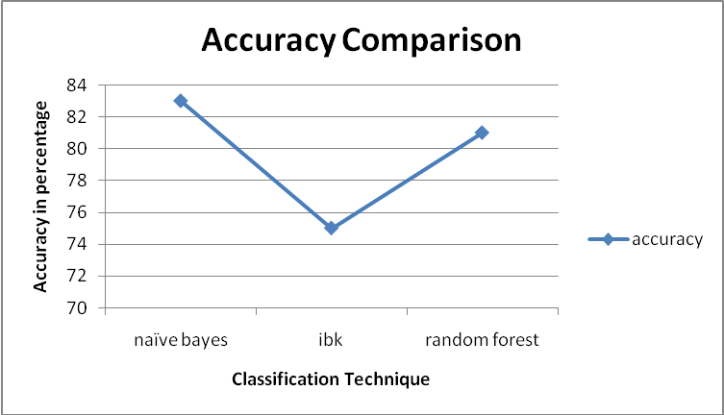
Figure 4: Accuracy comparison of the Classifiers

Conclusion and Futurework
This paper initially gives brief introduction about Data Mining, Weka tool and heart disease dataset. Weka is a powerful tool used in data mining techniques. The dataset contains 270 instances. The classification algorithms are classifying the data into correctly and incorrectly instances. We can use these algorithms in many areas like banking, medical and stock market analysis etc., finally we have analyses the naïve bayes classifier is better than other two methods of classification.

Futurework
Future research should concentrate on collecting data from a more recent time period and real symptoms record of the patients. Our dataset contains only 270 instances. This is very small work of a research. This work is extended up to large set of database and identifies the result in the help of two or three machine learning algorithms and then takes better approach from that performance; avoid taking repository datasets for future research.

Acknowledgment
The authors thank to Selvamm Arts and Science College for giving an opportunity to publish the paper. The authors also thank University of Waikato for WEKA tool availability as an open source.

References
- Pritam H.Patil, Suvarna Thube, Bhakti Ratnaparkhi and K.Rajeswari, “Analysis of Different Data Mining Tools using Classification, Clustering and Association Rule Mining”, International Journal of Computer Applications(0975-8887), Volume 93-No.8, May 2014.
- V.Manikantan & S.Latha, “Predicting the Analysis of Heart Disease Symptoms using Medicinal Data Mining Methods”, International Journal on Advanced Computer Theory and Engineering (IJACTE)-ISSN (Print):2319-2526, Volume-2, Issue-2,2013.
- S.Vijayarani and M.Muthulakshmi, “comparative Analysis of Bayes and Lazy Classification Algorithms”, International Journal of Advanced Research in Computer and Communication Engineering, Vol 2, Issue 8,August 2013.
- Divyansh Khanna, Rohan Sahu, Veeky Baths and Bharat Deshpande, “Comparative Study of Classification Techniques(SVM, Logistic Regression and Neural Networks) to predict the prevalence of Heart Disease”, International Journal of Machine Learning and Computing, Vol-5, No.5, October 2015.
- M.Akhil jabbar, B.L Deekshatulu and Priti Chandra, “ Classification of Heart Disease using K-Nearest Neighbor and Genetic Algorithm”, International Conference on Computational Intelligence: Modelling Techniques and Applications (CIMTA) 2013.
- Prerana T H M, Shivaprakash N C and Swetha N, “ Prediction of Heart Disease Using Machine Learning Algorithms- Naive Bayes, Introduction to PAC Algorithm, Comparison of Algorithms and HDPS”, International Journal of Science and Engineering Vol-3, Number 2-2015
- Vikas Chaurasia & Saurabh pal, “Early Prediction of Heart Disease Using Data Mining Techniques”, Caribbean Journal of Science and Technology, Carib.j.SciTech,2013, Vol.1,208-217.
- http://www.cs.waikato.ac.nz/ml/weka.
- http://repository.seasr.org/Datasets/UCI/arff.
- Jiawei Han, Micheline Kamber, “Data Mining: Concepts and Techniques, Third Edition”
- Rovina Dbritto, Anuradha and Vincy Joseph, “Comparative Analysis of Accuracy on Heart Disease Prediction using Classification Methods”, International Journal of Applied Information Systems(IJAIS)-ISSN:2249-0868, Vol-11 No 2, July 2016
- Md.Nurul Amin, Md.Ahsan Habib “ Comparison of Different Classification Techniques Using WEKA for Hematological Data”, American Journal of Engineering Research(AJER), Vol-4, Issue-3, pp-55-61
- Gayathri.P and N.Jaisankar, “Comprehensive Study of Heart Disease Diagnosis Using Data Mining and Soft Computing Techniques”, International Journal of Engineering and Technology(IJET) Vol 5 No 3 Jun-Jul 2013
- Umair Shafique, Fiaz Majeed, Haseeb Qaiser, and Irfan Ul Mustafa, “Data Mining in Healthcare for Heart Diseases”, International Journal of Innovation and Applied Studies ISSN 2028-9324 Vol. 10 No. 4 Mar. 2015, pp. 1312-1322
- K.Vembandasamy R.Sasipriya and E.Deepa, “Heart Diseases Detection Using Naive Bayes Algorithm”, IJISET - International Journal of Innovative Science, Engineering & Technology, Vol. 2 Issue 9, September 2015. ISSN 2348 – 7968
- Atul Kumar Pandey, Prabhat Pandey, K.L. Jaiswal, Ashish Kumar Sen, “ Data Mining Clustering Techniques in the Prediction of Heart Disease using Attribute Selection Method”, International Journal of Science, Engineering and Technology Research (IJSETR) Volume 2, Issue 10, October 2013
- Ruchika Rana, Jyoti Pruthi, “Heart Disease Prediction using Naive Bayes Classification in Data Mining”, IJSRD - International Journal for Scientific Research & Development| Vol. 2, Issue 05, 2014 | ISSN (online): 2321-0613
- Daljeet Kaur A and Aman Paul , “ Performance Analysis of Different Data mining Techniques over Heart Disease dataset”, International Journal of Current Engineering and Technology E-ISSN 2277 – 4106, P-ISSN 2347 - 5161 ©2014 INPRESSCO, Available at http://inpressco.com/category/ijcet
- Mythili T., Dev Mukherji, Nikita Padalia, and Abhiram Naidu, “A Heart Disease Prediction Model using SVM-Decision Trees-Logistic Regression (SDL)”, International Journal of Computer Applications (0975 – 8887) Volume 68– No.16, April 2013

