Empirical analysis of Contents Based Image Retrieval using Gabor Feature extractor

Brajesh Kr. Singh, Ravinder Kumar
Research Scholar USICT, Dept. of Computer Science &Engineering, HMRITM
GGSIPU, Dwarka, Affiliated to GGSIP University, Dwarka
Delhi, India Delhi, India
brajeshsingh.dce@gmail.comravinder_y@yahoo.com

____________________________________________________________________________________________________________
Abstract- Due to increase in multimedia and internet technology day-by-day the Content Based Image Retrieval(CBIR) is an attractive research area for computer vision researcher since last decade. There is various model of CBIR have been proposed for retrieving images from huge database. In this work, we present an empirical analysis of CBIR model using Gabor feature descriptors in MATLAB. The similarity is measure by Euclidian distance method between query image and data base image. The efficiency of the CBIR Model can be calculating using both precision and recall and all the experimental results shows that system performs well on five different standard datasets.

Keywords:Content-based Image Retrieval (CBIR), Gabor feature, Euclidian Distance
____________________________________________________________________________________________________________

- Introduction
The Content Based Image Retrieval (CBIR) is the field of study that concerned with looking, browsing and recovering digital images from an extensive database. The CBIR is becoming very popular because of the high demand for searching image from day-by-day growing database size. The problem become more challenging if database is too large. The CBIR is very effective tool for solving above problem and need of improvement is always desirable.The system algorithm is commonly divided into three major tasks.
- Feature extraction
- Similarity measure
- Retrieve Image from data base
The CBIR systems is basically extract description features from the query image and similarity is measure by specific method with feature database. After the similarity measuredthe similar kind images are retrieves from database. As we know CBIR system started from last few years ago there are several kind of technique has been proposed by many authors[2,3,4,6,7]. A generalize CBIR model is shown in figure 1.
Image Database: The database is consisting of the collection of ‘N’ number of images depends on the user rangeand choice.
Feature Extraction:The description of an image is called feature of image and it is described by color, texture and shape etc. In this stage of CBIR, visual description of eachdatabase image is extracted and saves them as features vectors in a features database.
Similarity Matching: The major task of CBIR system is that it searches the similar kinds of query image present or not in the database and retrieve the similar kind image, So the similarity measurement is a key stage of any CBIR system. Here is different distances method available such as Euclidian distance, Histogram Intersection, Bhattacharya distance etc. and using this distance method creates a distance vector of query feature vector and database feature vector.
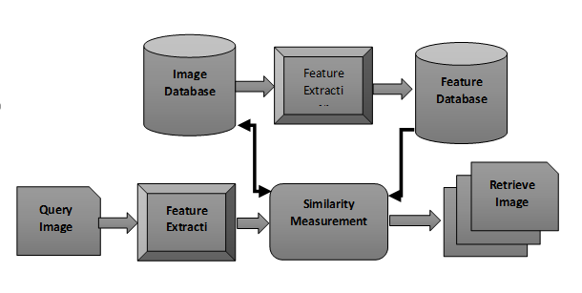
Figure 1. A generalized CBIR model

Retrieved images: At this stage of CBIR, find minimum distance vector with query image and corresponding Image is retrieve from Database [8]. In this paper, we use Gabor filter as feature descriptor and Euclidian distance method are used for similarity measurement for query and database image both.
At last the paper is organized as follows. In Section 2. Describe the overview of feature extraction methods, Section 3. Reviews some Similarity measure techniques used in Computer vision field. In Section 4. Proposed architecture of our CBIR system which is based on Gabor feature descriptor and all the experimental results are manipulated in Section 5. Finally Section 6 contains the conclusion and future work.

II. Feature extraction
Generally speaking the imagecontents hasbothvisualandsemanticcontent. The Visualcontentscanbe verygeneralordomainspecific like color,texture,shape,spatialrelationship, etc.In thissection, wefocusedonintroduction of features of an Image like:color feature, texture feature and shape feature, which are commonly used feature for computer vision purpose.

Color feature
We all know the real-worldimages are colorful and for the processing of color image, descriptor is very essential tool to distinguish and recognize the color image.
There are various color space have been available for the various purpose like HSV, RGB, CIE etc. [1]. The best color space is not defined for CBIR but we take perceptually uniformity color space. The color image representation is most widely uses RGB color space but it is not used in CBIR system due to its perceptually non-uniform behavior [2]. So, it is need forcolor feature extraction first we have toselect a specific color space anddevelop an effective descriptor for color image.Many color descriptors and representation schemes has developed like: color histograms [3], color moments [4], color edge [5], color texture [6], and color correlograms [7] etc.

1) Color Histogram: The histogram is basically a graphical representation of digital image by amount of pixel to a given pixel level [3], the intensity level of particular pixel is represented on x-axis and amount of particular intensity level pixel represent on y-axis shown in figure2. It is widely used method to represent the color feature of color image.
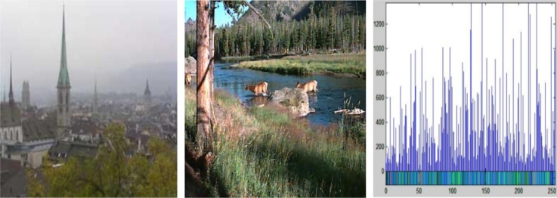

Figure 2(a) Image Properties, (b)Sample Image,(c) Histogram of Sample Image

2) Color Moments: The color moments is based on the assumption: The color distribution of an image can also be defined by probability distribution function and moments of that distribution can be used as a feature to identify thecolor image. Stricket et al [9] used three central moments of a color image i.e. mean, standard deviation and skewness.The color image has three color components Red, Green and blue and each of the color has three moments i.e.mean, standard deviation and skewness, so total nine moments have to calculatefor each color image.
Mean):First moment called average or mean and it is calculated by following formula:
$µ_{i}$ = $\frac{1}{M}\sum_{j=1}^{M}{f_{ij}}$ (1)
where M is total number of pixels in the image and$f_{ij}$ is the value of the $j^{th}$ pixel of the image at the $i^{th}$ color channel.
Standard Deviation ($σ_{i}$): Second moment is called standard deviation and it is calculated by taking the square root of the variance i.e.
$σ_{i}$ =$\sqrt{\frac{1}{M}\sum_{j=1}^{M}{{\left(f_{ij}−µ_{i}\right)}^{2}}}$ (2)
Where $µ_{i}$ is the mean value or first moment, for the $i^{th}$ color channel ofimage.
Skewness$\left(s | | i\right)$: The third moment is known as skewness. It is used to measure the color distribution and shapes knowledge about the color image. It can be computed by following formula:
$s_{i}$ = $\sqrt[3]{\frac{1}{N}\sum_{j=1}^{N}{{\left(f_{ij}−µ_{i}\right)}^{3}}}$ (3)

3) Color correlogram:The color histogram and color moments descriptors both are used to characterize spatial value or intensity but it does not characterize the relationship between spatial. The above drawback can be removed by characterizing the spatial correlation of color pairs or color Correlogram[10].Thefirstand theseconddimension ofthethree-dimensionalhistogram arethecolorsofany pixel pairandthethirddimensionistheirspatialdistance. A color correlogram is defined as a table indexed of a color pairs (i,j), where ‘i’ and ‘j’ specifies the probability of finding a pixel of color ‘j’ from a pixel of color ‘i’ at a distance ‘ k’ of the color image. Let we have an image ‘I’ of size N X N. The entire set of pixel of an image(I) is represented by I(x,y). The color is quantize into m-color i.e.$c_{1}$,$c_{2}$….$c_{m}$. and $I_{c\left(i\right)}$ represents the set of pixel of color c(i).
The color correlogram is defined as:

$γ_{i,j}^{\left(k\right)}={\underset{P_{1}∈I_{c\left(i\right)},P_{1}∈I_{}}{P}}_{r}$ (3)

Where i,j ϵ {1,2,…..,N}, k ϵ {1,2,….,d} and $\left|p_{1}−p_{2}\right|$ is distance between pixel $p_{1}∧p_{2.}$
Ifweconsiderallthepossiblecombinationsofcolorpairs thesize ofthecolor correlogramwillbeverylarge(O(N2d)), thereforeasimplifiedversionof the feature called the color autocorrelogramis often used instead. The colorautocorrelogramonlycapturesthespatialcorrelationbetweenidenticalcolorsand thusreducesthe dimensionto O(Nd).

- Texture Feature

The repetition of pixel pattern over spatial domain is known as texture feature.It gives information about spatial arrangement of intensities of an image or selected region of the image.The addition of noise in image the patterns and their repetition frequencies appear as a randomand unregular pattern. So, it is very useful for noise analysis also.
The human eye perceived different texture property like regular texture, directional texture etc. as shown in figures 3(a) to (d) and figure (e) and (f) shows complex texture image.
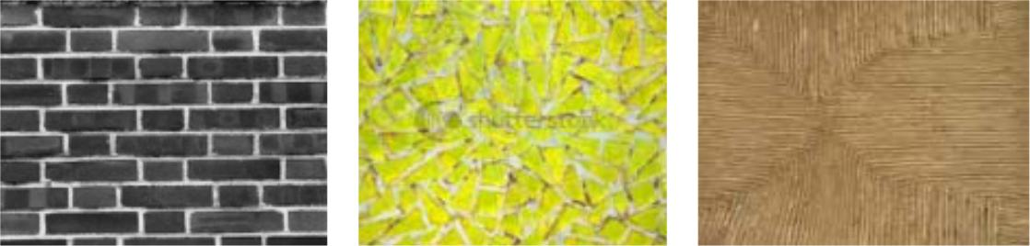

Fig 3(a) Regular texture(b)Irregular texture(c)Directional texture



(d) Non-directional (e) Complex texture1 (f) Complex texture2

There are two approaches are used to analysis the texture: structure approaches and statistical approaches.The structural approaches characterizetexturebyidentifyingstructural primitives andtheirplacement rules,it includingmorphologicaloperatorand adjacencygraph. It is moreeffectivewhen applied toveryregular textures.
The Statisticalmethodscharacterizetexturebythestatisticaldistribution oftheimage intensity.
The Gray-Level Co-occurrence Matrix [11] is mostly used method for statistical analysis of digital image. It includes Fourierpowerspectra,co-occurrencematrices,shift-invariant principal component analysis(SPCA),Tamurafeature,Wolddecomposition,Markovrandom field,fractalmodel,andmulti-resolution filteringtechniquessuchasGabor and wavelettransform. Local descriptor is also used forfeatureextraction of image. The application of local feature such as Local Binary Pattern (LBP), Local Directional Pattern (LDP) used by R.Kumar et. al. [21,22] as feature for finger print matching.

- Shape feature

Shapefeaturesofobjectsorregions are very important feature and it hasbeenusedinmanycontent-basedimage retrievalsystems (CBIR)[12, 13]. Shape features areusually describedafter imageshavebeensegmented into number of regions of the image. The stateart forshape description can be classified intoeitherboundary-based [14], polygonalapproximation [15],finiteelementmodels[16],Fourier-basedshape descriptors[17] and statisticalmoments[18] (region-based)methods. A goodshaperepresentationfeatureforan objectshouldbeinvarianttotranslation, rotation andscaling.

- Similarity measure

The similarity measurement is a very important stage because it directly affects the performance of any CBIR system. At this stage, we have to calculate the distance between twovectors(query image vector and database image vector) and produce a distance vector. Here is different distances method available such as Euclidian distance, Histogram Intersection, Bhattacharya distance etc.[20] The distance function is denoted by D(q,t).
Where ‘q’ is query image vector and ‘t’ is database image vector
Euclidian Distance; $D_{e}\left(q,t\right)$ = $\sqrt{\sum_{i=1}^{N}{{\left(q_{i}−t_{i}\right)}^{2}}}$ (4)

proposed mytholog
We propose a content base image retrieval (CBIR) system shown in figure (4). The model used Gabor filter for feature extraction of the image and Euclidian distance is used to measure similarity between query image and each of database images. It generates a distance vector with index value for the respective database image. The proposed system consists of two stages (i) Feature extraction and stored in feature database and (ii) feature matching andretrieving stage
- At the feature extraction stage:
- Convert image to a grey scale image.
- Gabor feature extracted of each of the database image and stored as *.CSV file in the feature database.
- Feature matching and retrieving stage:
- Gabor feature extract of query Image
- Euclidian distance is calculated between query image and each of the database image and store as a distance vector with index value.
- Distance vector is arranged in ascending with their corresponding index value.
- Smallest distance image is retrieve from image database with the help of corresponding index value
Image Database
base
Gabor feature Extractor
Gabor Feature Database
base
Query Image
Gabor Feature of Query Image

Euclidian Distance Calculate

Euclidian Distance Vector & Index

Min. Distance Vector & Index

Retrieve Image
Figure 4: Proposed CBIR Model

- PERFORMANCE EVALUATION AND RESULTS

The experiment on CBIR system was performed by using five different types of dataset i.e. cat, dog, lotus, mountain and nature dataset and each data set has fifty images. Total image in data set are 450. Five sample images from each five types of dataset are shown in figure (5)

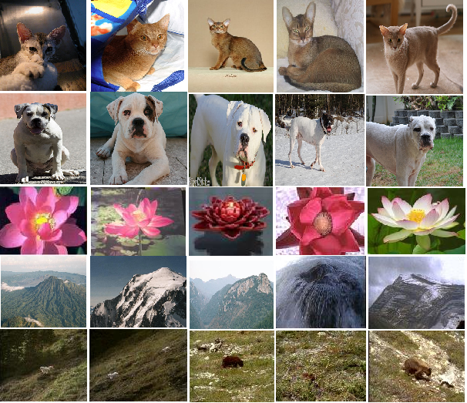

Fig (5): Five sample image from each five types of dataset

Top five imagesare taken from cat dataset and second top five images are taken from dog dataset as so on. This images also used as a query image
- Experimental result:
The Performance of CBIR system can be measured using precision and recall parameter.The precision measures the ability of the CBIR system to retrieve only the images that relevant

$$Precision=\frac{TruePositive}{TrurPositive+FalsePositive}$$

The recall measure the ability of CBIR system to retrieve all images that are relevant.

$$Recall=\frac{TruePositive}{TruePositive+Falsenegative}$$

Where, True Positive is a true image retrieve by the system in the result; false positive is an incorrect image retrieve by the system in the result; False negative is defined as the correct image that is not retrieved by the system.
All the experiment were performed on Dell studio 15 laptop with having configuration Intel Core i5 2.4 GHz Processor, 4 GB RAM and window 7 home premium 32 bit as an operating system. The CBIR System is implemented on MATLAB-13 and dataset were randomly selected for the testing of CBIR system.
Experiment were performed and retrieve images are obtained by figure window and precision and recall value by command window of MATLAB-13. In the experiment one query image is taken from each five class dataset and retrieve images are shown in figure 6(a), 6(b), 6(c), 6(d), and 6(e).Precision and recall value of respective query image are shown in table (1)

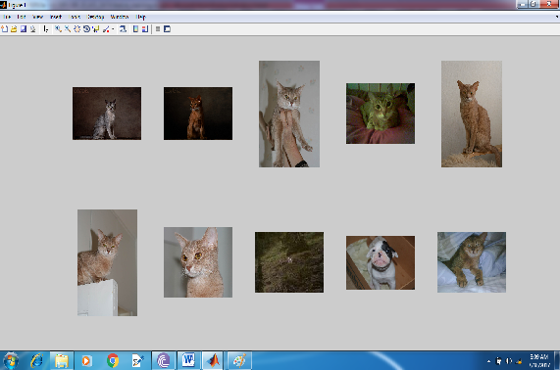
Fig (a) Cat images retrieve
As shown in figure (a), top left cat image is query image and reaming images are retrieved image from database by the CBIR systems

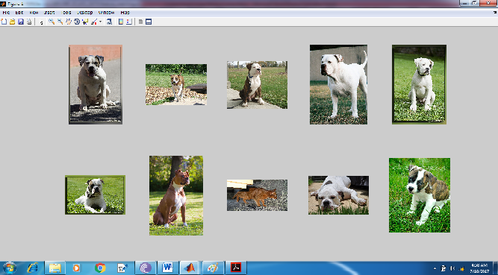
Figure (b) Dog images retrieve
As shown in figure (b) top left dog image is query image and reaming images are retrieved from database by the CBIR systems

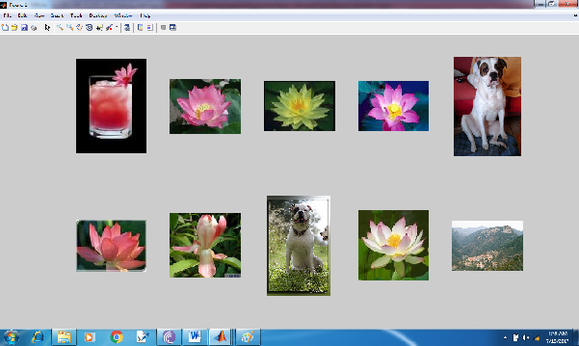
Figure (c) Lotus images retrieve
As shown in figure (c), top left lotus image is query image and reaming image are retrieved from database by CBIR systems

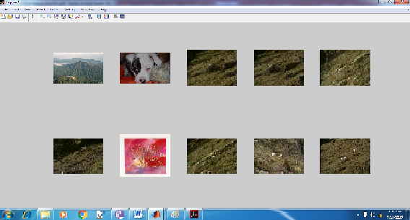
Figure (d) Mountain retrieve image
As shown in figure (d), top left mountain image is query image and reaming image are retrieved from database by CBIR systems

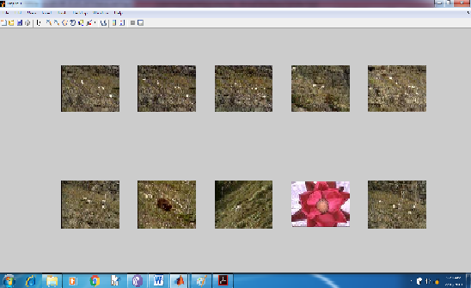
Figure (e) Nature images retrieve

As shown in figure (e), top left nature is query image at and reaming image are retrieved from data base by CBIR systems
TableI. Precision and recall value for given Query Image
Query Image | Recall | Precision
Cat | 0.8600 | 0.2462
Dog | 0.9400 | 0.4974
Lotus | 0.9800 | 0.1101
Mountain | 0.9400 | 0.1080
Nature | 0.9808 | 0.1001

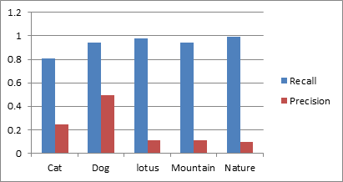

Figure (7) Recall and Precision graph

- Conclusion

Due to increasing of the social networking and multimedia technology day-by-day, CBIR is considered as an important research topic. This paper presents a CBIR system and in this system uses a Gabor Feature descriptor for extracting feature and Euclidian distance for similarity measurement. In the experiment the CBIR system retrieve many images relevant to query image in the feature space.
The Performance of proposed system is evaluated by precision and recall measurement. As a result performance the system consider as very competitive.

- References

[1] R. Gonzales, R. E. Woods, “Digital Image Processing,” 2nd Ed., New Jersey Prentice Hall, 2002.
[2] Gevers and A. Smeulders, “Pictoseek: Combining color and shape invariant features for image retrieval,” IEEE Trans. Image Processing, vol. 9, no. 1, pp.102– 119, Nov. 2000
[3] A. Ouyang, and Y. Tan, “A novel multi-scale spatial-color descriptor for content-based image retrieval,” Proceedings of the 7th International Conference on Control, Automation, Robotics and Vision, Mexico, August 2002, vol. 3, pp. 1204-1209.
[4] H. Yu, M. Li, H. Zhang, and J. Feng, “Color texture moments for content-based image retrieval,” Proceedings of the International Conference on Image Processing, Rochester, New York, USA S,ptember 22-25, 2002, vol. 3, pp. 929-932.
[5] T. Gevers, and H. Stokman, “Classifying color edges in video into shadow-geometry, highlight, or material transitions,” IEEE Transactions on Multimedia, vol. 5, no. 2, pp. 237-243, Sep. 2003.
[6] H. Guan, and S. Wada, “Flexible color texture retrieval method using multi-resolution mosaic for image classification,” Proceedings of the 6th International Conference on Signal Processing, vol. 1, pp. 612-615, Feb. 2002.
[7] H Moghaddam, T. Khajoie, and A. Rouhi, “A new algorithm for image indexing and retrieval using wavelet correlogram,” Proceedings of the International Conference on Image Processing, vol. 3, pp. 497-500, May 2003.
[8] H.B. Kekre, “Survey of CBIR Techniques and Semantics”, International Journal of Engineering Science and Technology (IJEST), ISSN: 0975-5462 Vol. 3 No. 5, May 2011.
[9] M. Stricker and M. Orengo, “Similarity of color images”, In SPIE Conference on Storage and Retrieval for Image and Video Databases III, volume 2420, pages 381392, Feb. 1995.
[10] J. Huang, et al., "Image indexing using color correlogram," IEEE Int. Conf. on Computer Vision and Pattern Recognition, pp. 762-768, Puerto Rico, June 1997.
[11]Haralick, K. Shanmugam, and I. Dinstein. “Texture Features for ImageClassification,” IEEE Trans. on Systems, Man and Cybernetics, SMC, vol.3, no 6, pp. 610–621, Nov. 1973.
[12] J. E. Gary, and R. Mehrotra, "Shape similarity-based retrieval in image database systems," Proc. Of SPIE, Image Storage and Retrieval Systems, Vol. 1662, pp. 2-8, 1992.
[13] W. I. Grosky, and R. Mehrotra, "Index based object recognition in pictorial data management," CVGIP, Vol. 52,
No. 3, pp. 416-436, 1990.
[14] H. V. Jagadish, "A retrieval technique for similar shapes," Proc. of Int. Conf. on Management of Data, SIGMOID’91, Denver, CO, pp. 208-217, May 1991.
[15] E. M. Arkin, L.P. Chew, D..P. Huttenlocher, K. Kedem, and J.S.B. Mitchell, "An efficientlycomputable metric for comparing polygonal shapes," IEEE Trans. Pattern Analysis and Machine Intelligence, vol. 13, no. 3, pp. 209-226, 1991.
[16] S. Sclaroff, and A. Pentland, "Modal matching for correspondence andrecognition," IEEE Trans. on Pattern Analysis and Machine Intelligence, Vol. 17, No. 6, pp. 545-561, June 995.
[17] K. Arbter, W. E. Snyder, H. Burkhardt, and G. Hirzinger, "Application of affine-invariant Fourier descriptors to recognition of 3D objects," IEEE Trans. Pattern Analysis and Machine Intelligence, vol. 12, pp. 640-647, 1990.
[18] M. K. Hu, "Visual pattern recognition by moment invariants," in J. K. Aggarwal, R. O. Duda, and A. Rosenfeld, Computer Methods in Image Analysis, IEEE computer Society, Los Angeles, CA, 1977.
[19] Long, H. Zhang, H. Dagan, and D. Feng, “Fundamentals of contentbased image retrieval,” in D. Feng, W. Siu, H. Zhang (Eds.):“Multimedia Information Retrieval and Management. Technological Fundamentals and Applications,” Multimedia Signal Processing Book, Chapter 1, Springer-Verlag, Berlin Heidelberg New York, 2003, pp.1-26.
[20] Qian, S. Sural, Y. Gu, and S. Pramanik, “Similarity between Euclidean and cosine angle distance for nearest neighbor queries,” Proceedings of ACM Symposium on Applied Computing, vol. 12, no. 22, pp. 1232-1237, 2004.
[21]Kumar, R., Chandra, P., & Hanmandlu, M. (2013, December). Fingerprint matching using rotational invariant image based descriptor and machine learning techniques. In Emerging Trends in Engineering and Technology (ICETET), 2013 6th International Conference on (pp. 13-18). IEEE.
[22] Kumar, Ravinder, Pravin Chandra, and Madasu Hanmandlu. "Rotational invariant fingerprint matching using local directional descriptors." International Journal of Computational Intelligence Studies 3, no. 4 (2014): 292-319.

