Analysing impact of various parameters on Water Quality Index
¹Divya Bhardwaj, ² Neetu Verma
¹Mtech Scholar, ² Assistant Professor
Department of Computer Science & Engineering, Deenbandhu Chhoturam University of Science and Technology, Murthal, Sonepat, Haryana

Abstract
Water is a limited natural resource. Therefore, preserving water is very important for protection of our environment. Various water quality monitoring systems have been developed to measure concentration of the constituents in quantity for characterisation of water for different uses. Water quality can be estimated through quality index which in turn is analysed through various parameters such as pH level, Turbidity, Dissolved Oxygen, Conductivity etc. This paper addresses the impact of parameters on water quality index. Moreover, the paper also depicts how water can be utilised based on various values of parameters.
Keywords: parameters, pH level, Turbidity, Dissolved Oxygen (DO), Electrical Conductivity(EC), Water Quality Index(WQI)
I. Introduction
A Water Quality Index (WQI) is a measure by which water quality can be estimated for various purposes. WOI can be used to predict whether the water is suitable for drinking purpose, industrial purpose or aquatic organisms etc. WQI can be measured on the scale 0 to 100. Higher the WQI , better is the quality of water. Below are the classifications of WQI:

Water Quality Index | Water Quality Status
95-100 | Excellent water quality
89-94 | Very Good water quality
80-88 | Good water quality
65-79 | Fair water quality
45-64 | Marginal water quality
0-44 | Poor water quality
Fig:1.1-Classification of Water Quality Index
WQI gets affected by various water quality parameters. In this paper effect of pH level, turbidity, dissolved oxygen (do) and electrical conductivity is analysed.

II. Effect of water quality parameters on WQI

i)pH Level

(Potential of Hydrogen) pH is the measure of hydrogen ions in the water. Water has hydrogen ions and hydroxyl ions. When there are equal numbers of both, the water is neutral. As the hydrogen ions (H⁺) increase, the water becomes more acidic; as the hydroxyl ions (OH⁻) increase, the water becomes more basic. pH is measured on a logarithmic scale of 0 to 14. 7 is neutral; less than 7 is acidic; more than 7 is basic.

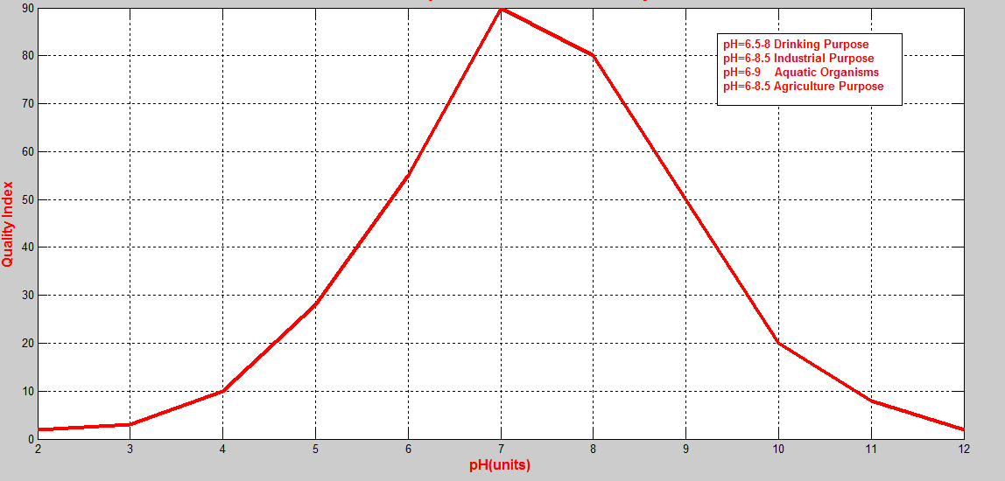
Fig:2.1- Effect of pH on WQI

Intially, when the pH is 0 unit, water quality is very poor. As the pH increases till 7 unit, water quality increases and is excellent. Above 7 units of pH, the water quality again starts decreasing and reaches to very poor.

(ii) Turbidity

Turbidity is an expression of the optical property that causes light to be scattered and absorbed. Turbidity in water is caused by suspended matter such as clay, silt, finely divided organic and inorganic matter, soluble coloured organic compounds etc.Turbidity is measured in Nephelometric Turbidity Unit (NTU).

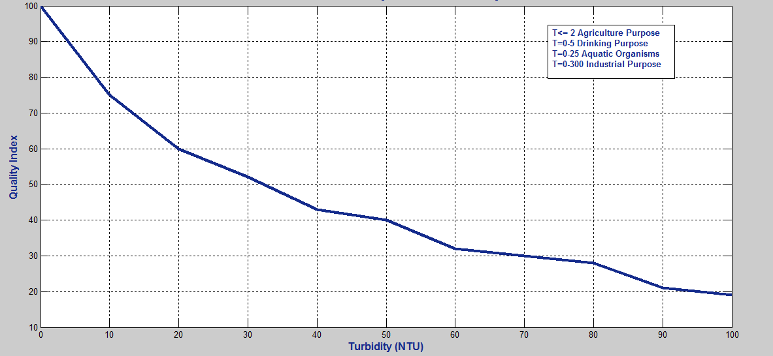
Fig:2.2- Effect of Turbidity on WQI.

As the amount of suspended, insoluble particles increases in water, turbidity increases which in turn decreases water quality.

(iii) Dissolved Oxygen (DO)

All living organisms depend upon oxygen to maintain the metabolic processes that produce energy for growth and reproduction. Dissolved oxygen is important in precipitation and dissolution of inorganic substances in water. DO is the basis of Biological Oxygen Demand test to evaluate pollution potential of wastes. DO is measured in milligrams per litre(mg/l).

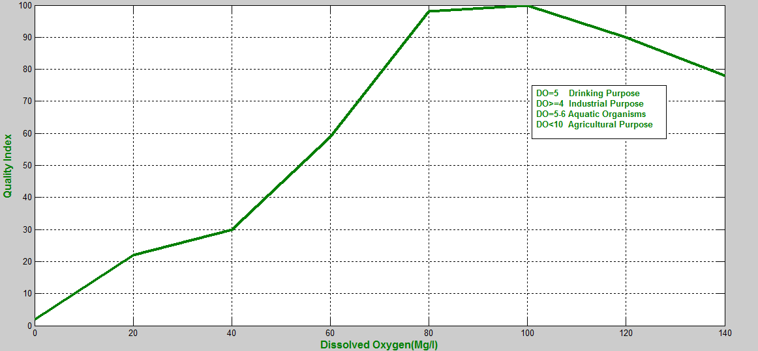
Fig:2.3- Effect of dissolved oxygen on WQI

WQI increases till dissolved oxygen value reaches to 100 mg/l. Above 100 mg/l, the WQI decreases and the water quality becomes very poor.

(iv) Electrical Conductivity

Conductivity is a measurement of the ability of an aqueous solution to carry an electrical current. An ion is an atom of an element that has gained or lost an electron which will create a negative or positive state. Conductivity and temperature are directly related.

III. Characterisation of water for different uses based on various parameters.

Water can be utilised for various purposes based on various water quality parameters. pH value, turbidity, dissolved oxygen, electrical conductivity are analysed to check suitability of water for drinking purpose, industrial purpose, aquatic organisms, agriculture purpose. Water quality parameters should satisfy certain so as to become suitable for these purpose. Parameters values are given below:

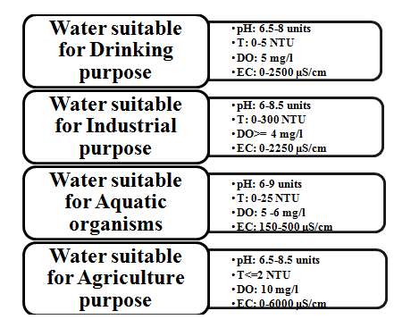
Fig:3.1- Characterisation of water for different uses

Where T= Turbidity, EC= Electrical Conductivity, μS/cm = microsiemens per centimetre, NTU=Nephelometric Turbidity Unit

IV. Results and Conclusions
WQI gets affected by various water quality parameters. These parameters should be carefully examined as they define the characterisation of water for different purposes. More parameters can be added to see observe their relationship with WQI. The parameters can be analysed for more purposes.
V. References
- Hanseok Jeong, Hakkwan Kim and Taeil Jang , Irrigation Water Quality Standards for Indirect Wastewater Reuse in Agriculture: A Contribution toward Sustainable Wastewater Reuse in South Korea Published, 23 April 2016.

- Kildea, T.N., and Andreacchio L, Adelaide Desalination Project: Salinity, pH and dissolved oxygen water quality data, marine exclusion zone. Australian Water Quality Centre, Adelaide. 10 pp, March 2012.

- Vijay S. Kale, Consequence of Temperature, pH, Turbidity and Dissolved Oxygen Water Quality Parameters, DOI 10.17148/IARJSET.2016.383

- Bondu Venkateswarlu, Dr.GSV Prasad Raju, Performance analysis and validation of clustering algorithms using soft computing techniques, (IJCSITS), ISSN: 2249-9555, Vol.6, No.2, Mar-April 2016.

- Hefni Effendi, River water quality preliminary rapid assessment using pollution index, The 2nd International Symposium on LAPAN-IPB Satellite for Food Security and Environmental Monitoring 2015, LISAT-FSEM 2015, Procedia Environmental Sciences 33 ( 2016 ) 562 – 567.

- Amruta Amit Joshi, Water Quality Monitoring System Using Zig-Bee and Solar Power Supply, International Journal of Advanced Research in Electrical, Electronics and Instrumentation Engineering (An ISO 3297: 2007 Certified Organization) Vol. 4.

- Steven Silva, Hoang N ghia Nguyen, Valentina Tiporlini and Kamal Alameh, "Web Based Water Quality Monitoring with Sensor Network: Employing ZigBee and WiMax Technologies", IEEE Conference on Local Computer Networks, IEEE 2011.

- Li Zhenan, Wang Kai, Liu Bo, "Sensor-Network based Intelligent Water Quality Monitoring and Control", International Journal of Advanced Research in Computer Engineering Technology, Volume 2, Issue 4, April 2013.

- Wireless Sensor Network based on Water Quality Monitoring System using Zigbee, Project Reference no. : 37s060

- Rao, A.S., Marshall, S., Gubbi, J., Palaniswami, M., Sinnott, R. and Pettigrove, V. , “Design of Low-Cost Autonomous Water Quality Monitoring System”, International Conference on Advances in Computing, Communications and Informatics (ICACCI), Mysore, 22-25, August 2013, 14-19.

- Lan gelier, W.F. Effect of temperature on the pH of natural waters. J. Am. Water Works Assoc., 38: 179, 1946.

- WHO, Guidelines for drinking water, Vol. 1, Recommendations, Geneva, 3rd Ed., ISBN 9789241547611, 2008.

